Background 1
Creating an MS Access Database 1
Creating Tables 2
Creating the ER Diagram 6
Adding Data 8
Exercises 9
Submission instructions: 10

Background
This document shows how to create an Entity Relationship diagram using MS Access. MS Access is useful to know for several reasons:
- It can serve as a useful small PC based database which permits queries, form, and report creation.
- It can help to prototype databases.
- It can be used to assist in data conversions.
- It can even be used to link different data sources through link tables.

It is a great tool to know and is used widely for testing and for developing proofs of concept for all many different enterprise databases.

Please note though that MS Access has difficulty with simultaneous transactions and does not handle writes well. For this reason it is not recommended as an enterprise solution. While MS Access is a great personal database tool for personal data management and prototyping it is not recommended for multi-user data management where simultaneous users need to manage data.

Regardless of your data management needs, knowledge of MS Access is essential.

Creating an MS Access Database

To create a database, launch Microsoft Access. From the File menu select New. Then select Blank Database.

2003 | 2007
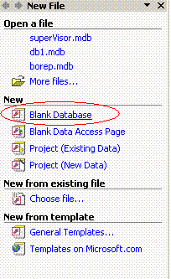 | 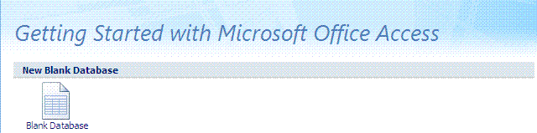

Selecting Blank Database will prompt you to simultaneously create and save a file. When prompted, navigate to a location that you can find, name the file, and press Create to save it. This example shows your MS Access file being named as db1.mdb.
2003 | 2007
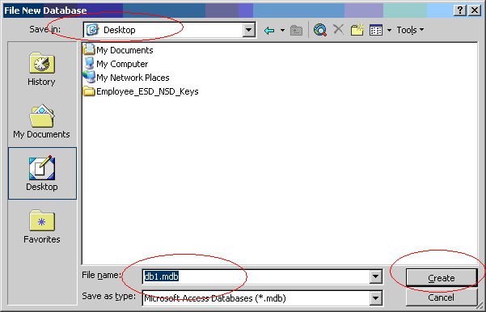 | 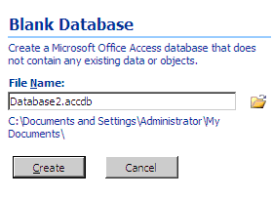

Creating Tables

This action will bring you to the panel where you can create tables. To create a table, select Create table in Design view and click New.

2003 | 2007
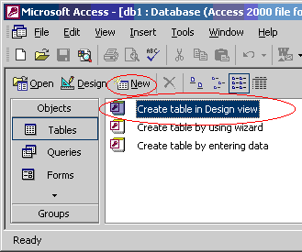 | 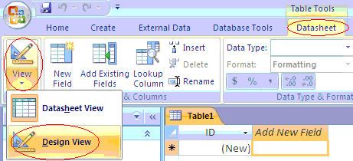

2003  Clicking New will launch the New Table dialog. To create a new table, select Design View and click OK. | 2007  Clicking Design View will trigger the save as dialog for the table. Enter the name customer and save it.
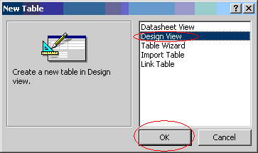 | 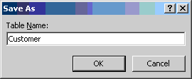

In Design View, you can add fields for the table, set the data type, and enter properties for items such as permitting NULL values.
2003 | 2007
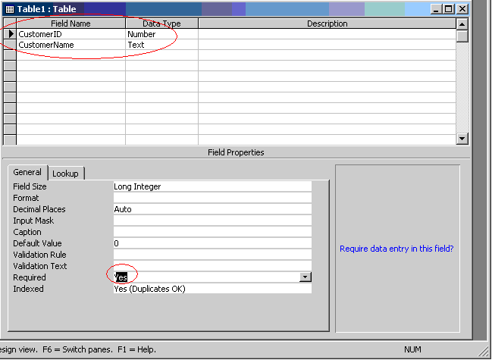 | 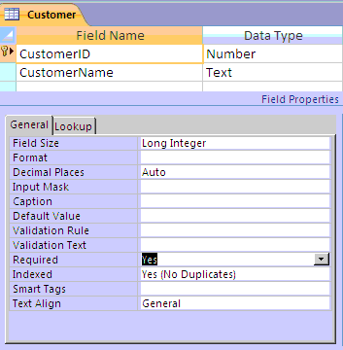

To set one of the columns as a primary key, right click the field and select Primary Key. This is the same for both versions and 2007 might have already added it in for you.
2003 | 2007
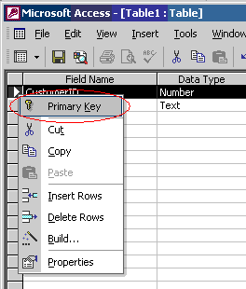 | 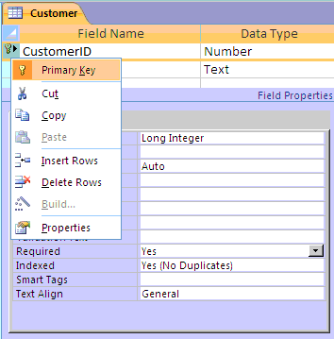

The primary key will then be denoted by the key sign.
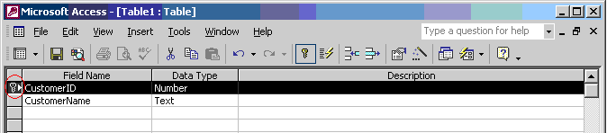

In 2003, clicking File | Save will trigger the Save As dialog where you can specify the table name. Enter the table name and click OK.
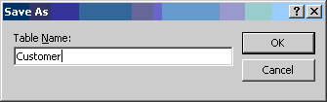

In 2003, after clicking OK, you will be returned to the menu where your Customer table will appear:
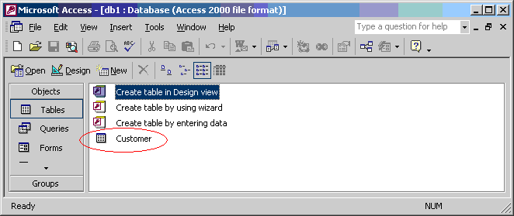

Next we will create an order table.
2003 | 2007  In 2007 a new table can be created by selecting the Create tab and Table.
 | 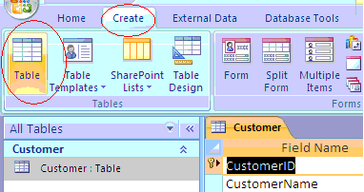

Use the steps listed above to create a table with the following properties:
2003 | 2007
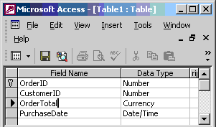 | 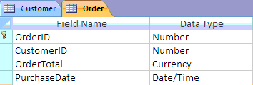

When complete, both the Customer and Order table should appear after saving the Order table:

2003 | 2007
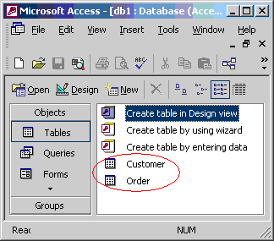 | 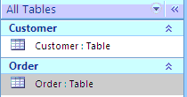

Creating the ER Diagram
You can launch the dialog to create the ER diagram by clicking the Relationships button. In 2007 you can find this on the Database Tools tab.
2003 | 2007
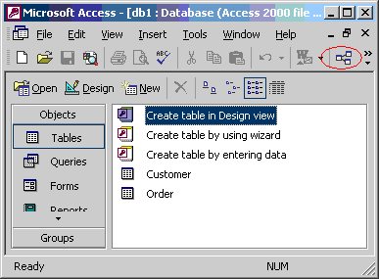 | 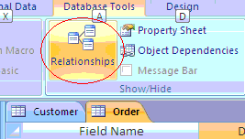

Select the Customer by clicking on it’s name and click Add:
2003 | 2007
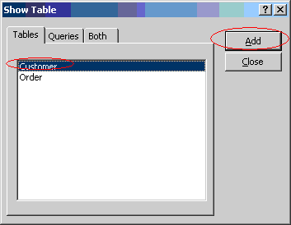 | 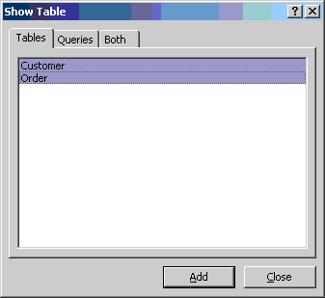

Clicking Add will launch the Relationships window. When it launches your Customer table and attribute listing should appear.
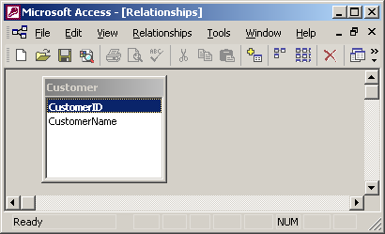

To add the Order table, click Relationships | Show Table. When prompted click Order and click Add. After, the two tables should appear in the Relationships dialog.
2003 | 2007
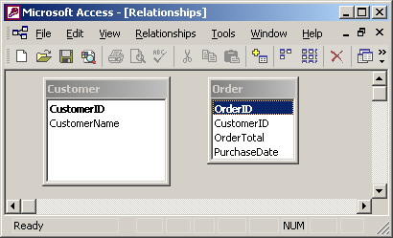 | 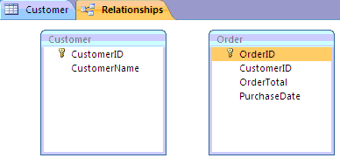

To create a link between the tables, left click CustomerID in the CustomerTable and while your left mouse button is pressed drag the cursor over the CustomerID field in the Order table. Then release the left mouse button. This will generate a join between your tables. Also, to enforce the join check Enforce Referential Integrity. Also, select Cascade Update Related Fields And check Cascade Delete Related Records so linked rows in other tables are removed if the matching primary key is deleted. . When finished click Create to show the join.

2003 | 2007
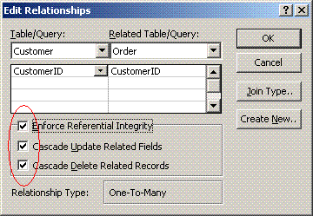 | 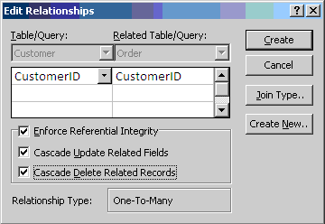

When finished your mini ER diagram will exist showing a one to many relationship between the customer and order table:
2003 | 2007
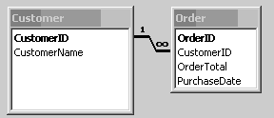 | 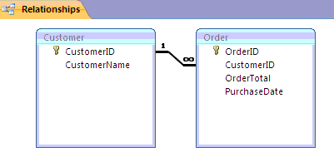

Adding Data
Here’s one way to get to the data entry screen but there are others.
2003  From the main menu, select a table and choose Design. | 2007  Right click the customer table
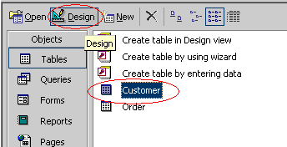 | 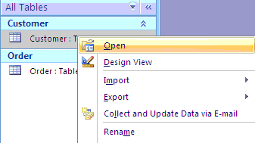

From the Design view select Datasheet View.
2003 | 2007
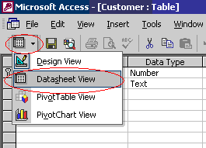 | 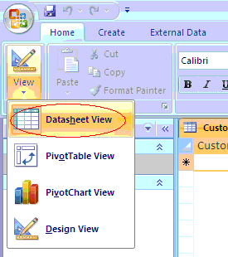

For each table that you view in Datasheet View you will be presented with a grid where you can enter data. Enter the following data for the Customer and Order tables.
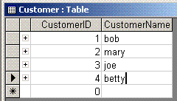
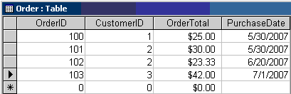

Exercises
- Follow all steps in this document. In the customer table, enter a fifth record:
CustomerID = 5 and CustomerName = your name (ie. If your name is Rita type Rita)
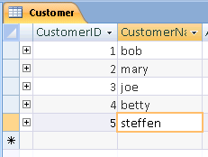

Take a screenshot of the customer table with your name as the CustomerName in the fifth field.

- Try and delete the row containing CustomerID=3 from the Customer table.
(a)Take a screenshot of the message and paste it into this document.

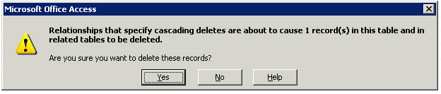

(b)Explain why the message appeared.

Referential integrity is being enforced and we have cascade deletes enabled. This means that when you delete a customer, who’s ID is associated with orders, the orders will be deleted as well.

(c)Explain how to modify your database so the message will not appear when deleting the row containing CustomerID=3 from the Customer table

Disable “Cascade Delete Related Records” in the relationships for the tables.

- In the Customer table, change joe’s customer number to 88.
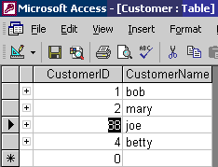
Notice that the CustomerID for joe’s order in the Order table is updated as well.
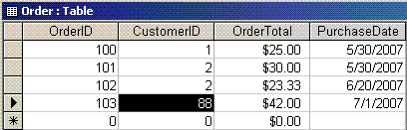
- Why does it get updated in the Order table?

The order table’s records get updated because we have “Cascade Update Related Fields” enabled, which automatically updates any related fields in order to maintain referential integrity.

- List one change to the database that you could make to prevent the CustomerID from being changed in the Order table when modifying the CustomerID in the Customer table.

To prevent the CustomerID from being changed in the Order table, you simply disable “Cascade Updated Related Fields” in the table relationships.

Submission instructions:
- Please add your answers by the questions in this document.
  - Due date to be announced in class.
  - Do this individually but you can speak with your neighbour for assistance.
  - Submit all answers in one document to your private folder (online later today).
  - In the subject line of your message please mark it Answers to MS Access ER Diagram.
  - Do not submit this as a word2007 document. Save it as *.doc.

